HIP Front Cover
HIP Version | Submitted by (Name) |  | HIP Date |  | Record Of Meeting Dates with KCC Virtual or Face to Face |  |  |  | County Member
 | Cllr Richard Ash |  | 18/12/2024 |  | 16/11/2019  5/3/2020  5/10/2021  19/04/2022  29.06.22 (HIP edit KCC)  28/10/2022 |  |  |  | Ie County Member, Parish Precept Donation, LTP bid
Please list below the funding opportunities/Sources for HIP initiatives/Measures |  |  |  |  |  |  |  |  | I.e., County Member, Parish Precept Donation, LTP
Are you an active member of the Speed Watch Scheme? |  |  |  | Yes ☐  No ☐ |  |  | Are you an active member of the Lorry Watch Scheme? |  | Yes ☐  No ☐
Name of HIP Representative |  |  |  |  |  | Contact Telephone Number |  |  |  | Email Address
Name of Clerk |  |  |  |  |  | Contact Telephone Number |  |  |  | Email Address
Name of Chair |  |  |  |  |  | Contact Telephone Number |  |  |  | Email Address
KCC Project Manager Team |  | Community & Engagement Team (WEST) |  |  |  | Contact Telephone Number |  | 03000 418181 |  | Email Address | west.highwayimprovements@kent.gov.uk
- Please note the Priority column MUST be those issues which are regarded as the most important (No 1 being your highest priority, then filtering down) KCC is unable to guarantee that all your requests will be deliverable, but Project Managers can investigate your top 1 or 2 priorities per year.
Live Priorities Record
Priority | Location | Problem/Concern | What do you feel are the potential solutions? | KCC Comments (This column is to be completed by Project Manager ONLY)
1. | The Landway | Dangerous parking opposite school entrance. Currently no restrictions meaning MBC unable to enforce. | Single yellow lines to restrict parking during school drop off/pick up times only. Extend zigzag lines round the corners.  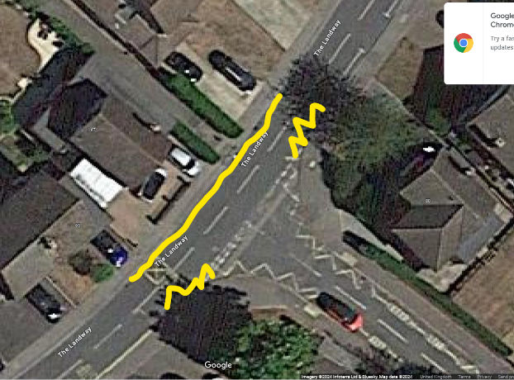 | 21/02/25 -  P&A to assess parking restrictions as per the drawing here. School area gets very congested at drop off/pick up times, the idea here is to create a zone free of parked cars outside the school.
2. | Roundwell | There is a crossing point serving the Sycamores development, but speeding cars are a concern due to sight lines to the east. | A buildout on the southside of the crossing (like the one at Bearsted station) so west bound traffic must give way. | 21/02/25 -  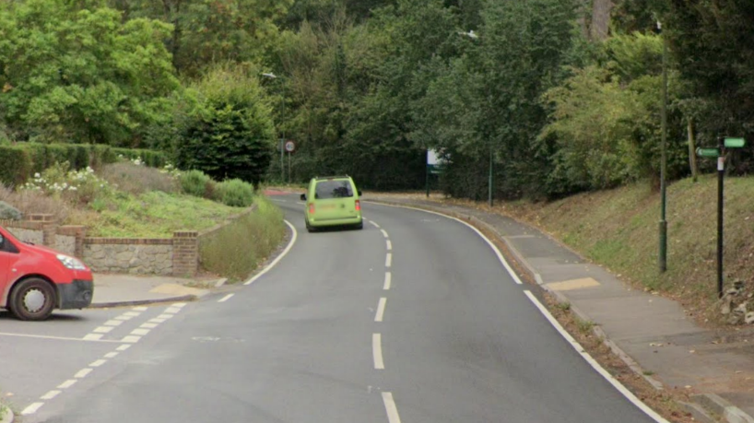  This is the crossing in question. When crossing right to left, the sightlines for both peds and vehicles is very limited due to curvature of the road.  GM in first instance to order speed surveys and then see if we can install a junction warning sign and/or elderly crossing sign.  Build out will not be possible here unfortunately, as it could potentially lead to more danger as the sight lines are poor and it is very close to where the speed limit changes.
3. | Ashford Road (50m East of Esso Garage) | The crossing point is a traffic island and there is a lot of pedestrian movement across the road at this point. | A pedestrian refuge island at the point. | 21/02/25 - This is technically possible, but funding will need to be identified for this. There is possibility of a funding bid in 2026, but this is not a guarantee. GM to check with P&A the viability, then discuss with PC any future funding potential.
4. | Manor Close junction with Yeoman Lane | Inconsiderate parking causing access egress issues from Manor close/court into and out of Yeoman Lane | DYLs extending to Manor Court/ 15 Manor Close. | 21/02/25 - Agreed with the PC to do corner protection at junction of Manor Court and Yeoman Lane
5 | Sandy Mount | Cars parked on the bend, which is quite tight and you cannot see all the way round. Have to drive in the oncoming lane, which is quite dangerous. | DYLs on both sides of the road on the bend.  N.B. Latest plan for Sandy Mount agreed which differs to original proposal. | 06/12 - Can we install DYLs like the below image:  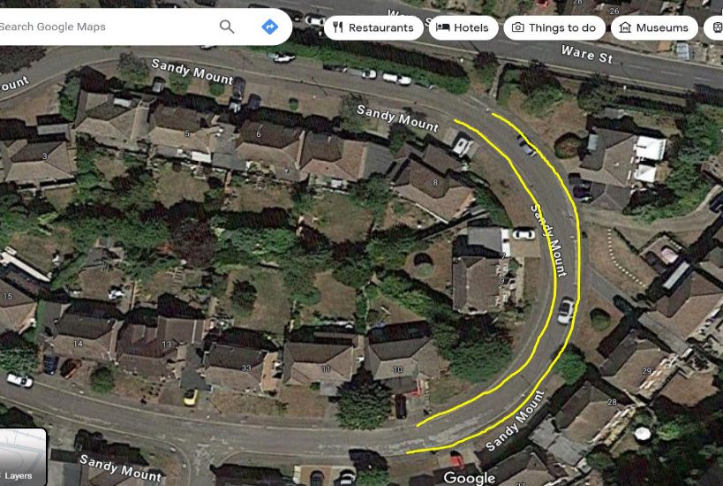  11/04/24 In the first instance the resident should try and extend their dropped kerb, if this doesn’t work, we can consider some double yellows, but the extents would be smaller than the above suggestion.  21/02/25 - Lines all approved and this is underway.
6 | Church Lane | Speeding traffic lack of footpaths by the church and from the Green. | Some signage warning of pedestrians in the road. | 21/02/25 - This was investigated previously and unfortunately no suitable location for KCC to install signage here.
7 | Ashford Road East | There are no crossing points. A footpath crosses the A20 and there are bus stops, traffic tends to speed up here. | A pedestrian refuge island on the A20 in the vicinity of Otham Lane or to the west of the 30mph gateway on the A20. | 21/02/25 - There were issues with an island by Otham Lane, mainly because of the proximity to the junction and sightlines. There is a turning lane for Otham Lane and the island would need to go outside of this, which puts it right by the 30 gateway.  What are pedestrians trying to reach? There is the bus stop, but the footway from this takes pedestrians in to Bearsted, where there are further crossing points.

Historical Priorities Record
No | Location | Problem/Concern | What do you feel are the potential solutions? | KCC Comments
 | Ware Street | Pedestrian Safety  There are no pedestrian crossings between Rail Bridge & Station despite discontinuous pavements on both sides of Ware Street.  Cars travelling in excess of 30mph | Consider pedestrian crossing plus speed mats:  - East of Rail Bridge, just before Chapel Lane  - Outside No 64a across to East of Sandy Lane.  - By entrance to Goods Yard. At the very least a dropped kerb is required opposite the vehicular access to the train station to allow wheelchair and mobility scooter users to cross  Slow traffic with rumble strips on approach to bridge.  Improved village gateway at Bell bridge  More visible 30mph road markings/ road narrowing markings.  Speed Indicator Devices | BPC requested pedestrian warning signs be placed on RHS of Bell Bridge (EB). Permission request form from Network Rail sent to KCC for action 29/04/ 2021  BPC speed survey carried out May 2021. Results forwarded to KCC July 2021  4/10/21 - KCC to carry out site visit to look at suitable location for pedestrian warning signs –  7/12/21 – Discussed with Parish Council and advised that this is not possible due to layout of road.  Site visit to be carried out to look at eastern side of bridge crossing point  29.06.22 - KCC will look to reassess this early Autumn.  25.10.22 - Drop crossing opposite ped entrance to station GM believes to be the best place, kerb build out might be necessary. Ped count may be necessary to determine need.  Gateway can be improved, this will cost minimum £1000. This isnt very visible from the approach to it.  Slow marking can be placed next to the in situ road narrows sign. Rumble strips are not used in residential area, due to noise and vibration.  30mph roundels are prohibited unfortunately, due to street lighting. Slow marking can be placed next to road narrows sign.  For a SID, please contact toby.butler@kent.gov.uk, please bare in mind there is strict criteria for these.  28.10.22 - Gateway on the footway on the opposite side to the current sign has been discussed. GM and ET to raise enquiry to P&A regarding the feasibility of this. If not feasible, will ask P&A to look into options to slow the speed of traffic approaching the bridge from the west, to allow pedestrians to cross easier.  P&A to also explore the option of a dropped kerb to the pedestrian entrance to the train station.  CSM 12408811.  31/01/23 - PC to decide on whether they would like to take the build out forward. Design fee will be £1879, works estimated to then be around £15,000.  05/07/23 – Design is just awaiting sign off from management
 | A20 Ashford Road | Speeding Traffic  Vehicles travelling at 60mph + at National speed limit suddenly entering 30mph built up area and failing to adhere to this sudden change in speed limit. Excessive speeds being recorded. | Extend start/end of 30mph zone to village boundary opposite Gore Cottage OR  Make start of 30mph zone more visible AND  Reduce speed limit from national speed limit to 40mph from Roundwell/ A20 Junction. Speed review based on crash history, change in use of side roads, new car park, tailgating, residents support and speed surveys.  Clearly defined 50/40/30mph zones from Hollingbourne as on the A20 through Harrietsham  Cycle lane | 06/10/23 - Please see historical section for further notes on gateway improvements. Current status of the cycle lane is that we are seeking further advice on how to proceed, as this is a very large project. Potential for a LTP bid.
 | Ware Street - Random parking from rail bridge to Sandy Lane on N side of Street, including on blind corner, causing danger to pedestrians, oncoming traffic & obstructing vehicles | Following,initial informal consultation, a revised plan is being submitted to include double yellow lines on blind bend only | KCC | Awaiting revised drawing from KCC  BPC to inform residents of revised plan – Informal consultation carried out  TRO sent to Robin to progress – PC funding Order raised for DYLs to be installed WORKS COMPLETE
 | A20 Ashford Rd junction at Spot Lane  & Roseacre Lane. Vehicles unable to exit  Spot Lane due to busy, speeding traffic on Ashford Rd. Then faced with 'head on traffic' trying to exit Roseacre Lane. | Consider mini roundabout or traffic lights on A20 | Possibly S106
 | Church Lane HGV's taking short cuts through village, along Roundwell & The Street, and trying to access A20 by going up Church Lane | Requires prominent No Through Road signs, plus possibly Not Suitable for HGV's at The Street entrance to Church Lane | KCC | 25/11/19 - Job raised for no through road sign – 12403751  WORKS COMPLETE
 | Roseacre Lane/Hogg Hill  Used as 'rat run' between A20 and Ware Street. Roseacre extremely narrow. Speeding a serious issue. Unsuitable for larger vehicles. | Traffic calming/speed humps along Roseacre Ongoing complaints about speeding traffic cutting through  More prominent 'Not Suitable for HGV's' signs  Weight restriction signs (7.5T) at both ends of Roseacre |  | Agreed to add SLOW markings next to signs, install additional 20mph and roundels – Job raised 26/9/19 Works complete  Speed survey carried out – Results sent to parish council
 | A20 Ashford Road (East of Tesco Express)  Children cross the road from school bus, using central traffic island.  Currently there are SYL's on both sides of road. Cars parked to the East of traffic Island impair site line of vehicles travelling West Otham Lane – Increasingly used as a 'rat run'. Speeding vehicles a serious problem | Consider formal pedestrian crossing or double yellow lines on both sides of Ashford Road and extend those on South side by 15 metres  Carry out traffic survey 150-200 metres from junction with A20 to verify extent of problem. If justified implement traffic calming |  | Assessment carried out – not successful. The island is not a pedestrian island and would encourage pedestrians to use the crossing facility.  No further action
 | Manor Rise – parked cars blocking access to track behind houses on Yeoman Lane | Additional DYL's to replace Keep Clear road marking plus additional DYL's on corners further down road -  See drawing |  | As this is a residual problem from putting DYL's at top of Manor Way BPC have produced plan to show proposed areas for additional DYL's  Assessment carried out – Does not meet criteria
 | Cavendish Way and Copsewood Way Dangerous parking on corner | Corner protection requested Request for residents only parking |  | Assessment carried out 6/11/19 Plan sent to parish council so they can carry out informal consultation with residents  OBJECTIONS RECEIVED SO NOT TO BE TAKEN FORWARD – NO FURTHER ACTION  13/5/20 – Residents only parking is responsibility of MBC
 | Spot Lane and Royston Road Dangerous parking on corner | Corner protection requested |  | Assessment carried out 6/11/19 Plan sent to parish council so they can carry out informal consultation with residents  No objections received – Formal TRO to be progressed  17/8/20 - Works order raised – 12404194 –  WORKS COMPLETE
 | Royston Road junc. with Madginford Road and opp. Junction up to Spot Lane both sides | DYL Requested |  | Assessment carried out 6/11/19 – Plan sent to parish council so they can carry out informal consultation with residents  No objections received – Formal TRO to be progressed  17/8/20 - Works order raised – 12404194 – NFA  WORKS COMPLETE
 | Rosemary Road and Romney Close (off Ashford Road) | Corner protection requested |  | Assessment carried out 6/11/19 – Plan sent to parish council so they can carry out informal consultation with residents  No objections received – Formal TRO to be progressed  17/8/2020 – Works Order Raised – 12404193 – NFA  WORKS COMPLETE
 | Egremont Road & Eastern junc. with Merton Road (By car park for shops) | DYL requested |  | Assessment carried out 6/11/19 – Plan sent to parish council so they can carry out informal consultation with residents  No objections received – Formal TRO to be progressed  17/8/2020 – Works Order raised – 12404189 – NFA  WORKS COMPLETE
 | Egremont Road, by shops. Both corners of access road to library/ hall | DYL requested |  | Assessment carried out 6/11/19 – Plan sent to parish council so they can carry out informal consultation with residents  No objections received – Formal TRO to be progressed  17/8/2020 – Works Order raised – 12404189 – NFA  WORKS COMPLETE
 | Tydeman Road – Junction with Merton Close | Corner protection requested |  | Assessment carried out 6/11/19 – Plan sent to parish council so they can carry out informal consultation with residents  No objections received – Formal TRO to be progressed  17/8/2020 – Works Order raised – 12404190 – NFA  WORKS COMPLETE
 | Madginford Road junction with Madginford Close | DYL requested |  | Assessment carried out 6/11/19 – Plan sent to parish council so they can carry out informal consultation with residents  No objections received – Formal TRO to be progressed  17/8/2020 – Works Order Raised – 12404188 – NFA  WORKS COMPLETE
 | The Landway junction with Fullers Close  Dangerous parking at school times | DYL requested on both corners |  | Assessment carried out – Plan sent to parish council so they can carry out informal consultation with residents  PARISH COUNCIL HAVE ADVISED NOT TO PROCEED  NO FURTHER ACTION
 | The Landway junction with The Sprig  Dangerous parking at school times | DYL requested on both corners Request for 13 metre stretch of DYL into The Sprig to be reduced to 10m  Single yellow lines in rest of cul de sac with no parking between 1.30-2 to prevent commuter parking |  | Assessment carried out – Plan sent to parish council so they can carry out informal consultation with residents  OBJECTION RECEIVED – PARISH COUNCIL TO SPEAK TO OBJECTOR  13/5/20 – KCC to change plan to 10m corner protection as requested by Parish Council  PLAN CHANGED TO 10M – FORMAL TRO TO BE PROGRESSED  17/8/2020 – Works Order raised – 12409195 – NFA  WORKS COMPLETE
 | The Landway junction with Almonds  Dangerous parking at school times | DYL requested on both corners |  | Assessment carried out –Plan sent to parish council so they can carry out informal consultation with residents  OBJECTION RECEIVED – PARISH COUNCIL TO SPEAK TO OBJECTOR  FORMAL TRO TO BE PROGRESSED  17/8/2020 – Works Order raised – 12409195 – NFA  WORKS COMPLETE
 | The Landway junction with Spurway  Dangerous parking at school times Request for White lines across driveways | DYL requested on both corners |  | Assessment carried out – Plan sent to parish council so they can carry out informal consultation with residents  OBJECTION RECEIVED – PARISH COUNCIL TO SPEAK TO OBJECTOR  13/5/20 – Dog bone are not permitted FORMAL TRO TO BE PROGRESSED  17/8/2020 – Works Order raised – 12409195 – NFA  WORKS COMPLETE
 | Egremont Road Speeding | More information required – Speed survey to be carried out |  | Will monitor
 | Ashford Road – Limited parking outside Chemist/post office | Maximise available parking space once building works finished and scaffold removed  Needs 30 minute waiting restriction |  | PC to speak to MBC
 | Egremont Road | Request for repainting of bus stop sign on road |  | 13/5/20 – To be assessed – Advised Parish council to log on WAMS  Reported by BPC 8/6/2020 Ref: 508693
 | Mallings Lane – Commuter and 'long term' parking causing difficulty for residents to access drives | Single yellow lines with 'time break' requested for both sides |  | Assessment carried out 6/11/19 – Does not meet criteria  NFA
 | Ragstone road | Request for bollards outside number 49 Ragstone Road to prevent mounting and erosion of pavement |  | 17/3/21 – No plans to install bollards at this location  No further action
 | Clarendon Close junction with Roseacre Lane | What is the problem?  Request for double yellow line corner protection |  | 13/5/20 – To be assessed  11/6/21 – Assessed – not to be progressed. No issues found
 | Yeoman Lane | Pedestrian safety.  No footway for part of the lane.  Used as 'rat run' between A20 and Ware Street. Speeding cars & motorbikes a serious issue. | Unsuitable for HGV’s Traffic calming Speed indicator devices  More prominent 'Not Suitable for HGV's' signs | BPC carried out new traffic surveys May 2021. Results forwarded to KCC July 2021  Speed survey carried out – Results sent to parish council  17/3/21 - Will look at replacing existing HGV lorry signs with lorry symbol signs  29/4/21 - Job raised for new advisory lorry signs
 | Ragstone Road/ Greensands Road | Dangerous and inconsiderate parking during school times. | Request for increased patrols/ DYLS | MBC function to enforce double yellow lines – 28/1/22 – Assessment carried out to take forward double yellow line corner protection  25/10/22 - This
 | The Grove junction with Roseacre Lane | Request for dropped kerb |  | 04/11/22 - There are already crossing points down The Grove and we cannot install one onto Roseacre Lane as there is no footway.
 | Roseacre Lane | Used as 'rat run' between A20 and Ware Street. Roseacre extremely narrow. No footway. Popular pedestrian school route. Speeding a serious issue. Unsuitable for larger vehicles.  Concerns that proposed resurfacing will increase speeding. | Incorporate traffic calming measures into resurfacing works.  Limit access. Prioritise pedestrians. | Agreed to add SLOW markings next to signs, install additional 20mph and roundels – Job raised 26/9/19 Works complete  Speed survey carried out – Results sent to parish
 | Romney Close cul de sac | Dangerous parking hindering visibility and access /egress. | Request for DYL’s on the corner of Romney Close (the cul -de -sac | 25/10/22 - These requests for DYLs will need to be priortised, as we will be unable to process all of them. TRO cost is £2500 and the lining working itself is likely to be around £150 for each set of lines.  28/10/22 - DYL priority No3. GM and ET to discuss with P&A, there is already a TRO being written for Maidstone district. This could potentially be added on.  04.11.22 - This appears to have been completed.
 | Otteridge Road/junction with Tower Lane | Inconsiderate parking | BPC monitoring | 04.11.22 - NFA due to BPC continuing to monitor
 | Sandy Lane | Beyond Mount Pleasant Drive the lane is very narrow with steep banks. Impossible for pedestrians to get out of the way of cars which are driving up the lane and exiting via Hogg Hill as is necessary | Request that Sandy Lane is made 2 way from just beyond Mount Pleasant Drive down to Ware Street and that Sandy Lane beyond Mount Pleasant is made a no through road and accessible only by emergency vehicles and utility companies | 26.06.22 - This road already has an ‘except for access’ prohibition which Kent Police manage the enforcement of. KCC would not seek to restrict all vehicles using this road by reducing the status of our asset. It is likely that it is locals ignoring the current prohibition and without any enforcement or physical measures drivers would likely ignore any further notices/reclassification. The District Manager is in agreement.  NFA  28.10.22 - KCC would be unable to support making Sandy Lane two way, however should the Parish Council wish to pursue a stopping up order this is not something that we could assist with via the HIP process, but further information can be found on-line at Highways permissions and technical guidance - Kent County Council.
 | Cavendish Way/ Copsewood way | Dangerous and inconsiderate parking on junction of Copsewood Way and Cavendish Way and opposite the junction | Request for DYL’s on both corners of the junction and opposite the junction.  AND/OR Central island to restrict parking | 25/10/22 - These requests for DYLs will need to be priortised, as we will be unable to process all of them. TRO cost is £2500 and the lining working itself is likely to be around £150 for each set of lines.  28/10/22 - DYL priority No1. GM and ET to discuss with P&A, there is already a TRO being written for Maidstone district. This could potentially be added on. We need further clarification on this from the PC as there is a record implying that the Parish did not wish to proceed with this due to objections.  31/01/23 - Comment from P&A: Normally we only look to install double yellow lines where there is a safety critical element or as part of a crash remedial measure, neither apply at these locations. The parish could liaise with the Borough Council parking department, to establish whether the Borough would be willing to implement and enforce these lining requests. If the Borough are not willing to enforce the lines, they wont have any effect. If after consulting with the Borough the PC wish to proceed, they will have to look at funding the whole scheme themselves.
 | Copsewood Way/ Yeoman Way | Dangerous and inconsiderate parking on corner of junction | Request for DYLs on both corners | 25/10/22 - These requests for DYLs will need to be priortised, as we will be unable to process all of them. TRO cost is £2500 and the lining working itself is likely to be around £150 for each set of lines.  28/10/22 - DYL priority No2. GM and ET to discuss with P&A, there is already a TRO being written for Maidstone district. This could potentially be added on.  31/01/23 - Comment from P&A: Normally we only look to install double yellow lines where there is a safety critical element or as part of a crash remedial measure, neither apply at these locations. The parish could liaise with the Borough Council parking department, to establish whether the Borough would be willing to implement and enforce these lining requests. If the Borough are not willing to enforce the lines, they wont have any effect. If after consulting with the Borough the PC wish to proceed, they will have to look at funding the whole scheme themselves.
 | Copsewood Way/ Yeoman Way | Dangerous and inconsiderate parking on corner of junction | Request for DYLs on both corners | 25/10/22 - These requests for DYLs will need to be priortised, as we will be unable to process all of them. TRO cost is £2500 and the lining working itself is likely to be around £150 for each set of lines.  28/10/22 - DYL priority No2. GM and ET to discuss with P&A, there is already a TRO being written for Maidstone district. This could potentially be added on.  31/01/23 - Comment from P&A: Normally we only look to install double yellow lines where there is a safety critical element or as part of a crash remedial measure, neither apply at these locations. The parish could liaise with the Borough Council parking department, to establish whether the Borough would be willing to implement and enforce these lining requests. If the Borough are not willing to enforce the lines, they wont have any effect. If after consulting with the Borough the PC wish to proceed, they will have to look at funding the whole scheme themselves.
 | Lenside Drive/Spot Lane | Dangerous/inconsiderate parking at the junction of Lenside Drive with Spot lane | Request for DYL corner protection. | 25/10/22 - These requests for DYLs will need to be priortised, as we will be unable to process all of them. TRO cost is £2500 and the lining working itself is likely to be around £150 for each set of lines.  31/01/23 - Comment from P&A: Normally we only look to install double yellow lines where there is a safety critical element or as part of a crash remedial measure, neither apply at these locations. The parish could liaise with the Borough Council parking department, to establish whether the Borough would be willing to implement and enforce these lining requests. If the Borough are not willing to enforce the lines, they wont have any effect. If after consulting with the Borough the PC wish to proceed, they will have to look at funding the whole scheme themselves.
 | Roundwell junction with Sutton Street | Dangerous parking on western corner. DYL requested |  | 28/1/22 – Assessment carried out – Happy to take forward but need to check with parish council regarding car parked on pavement first  25/10/22 - These requests for DYLs will need to be priortised, as we will be unable to process all of them. TRO cost is £2500 and the lining working itself is likely to be around £150 for each set of lines.  31/01/23 - Comment from P&A: Normally we only look to install double yellow lines where there is a safety critical element or as part of a crash remedial measure, neither apply at these locations. The parish could liaise with the Borough Council parking department, to establish whether the Borough would be willing to implement and enforce these lining requests. If the Borough are not willing to enforce the lines, they wont have any effect. If after consulting with the Borough the PC wish to proceed, they will have to look at funding the whole scheme themselves.
 | Church Lane (between the Church & Trapfield Close) | Narrow road, suitable for one vehicle, leads to confrontation | Give way sign either going up or down, providing clear instruction on right of way | 06/12 - We can only install signage for priority where there is a specific priority build out or section. We could look to install road narrows signs, but the location is very limited for where signs can go.  06/12 - Can we install this signage at the end of the footway?  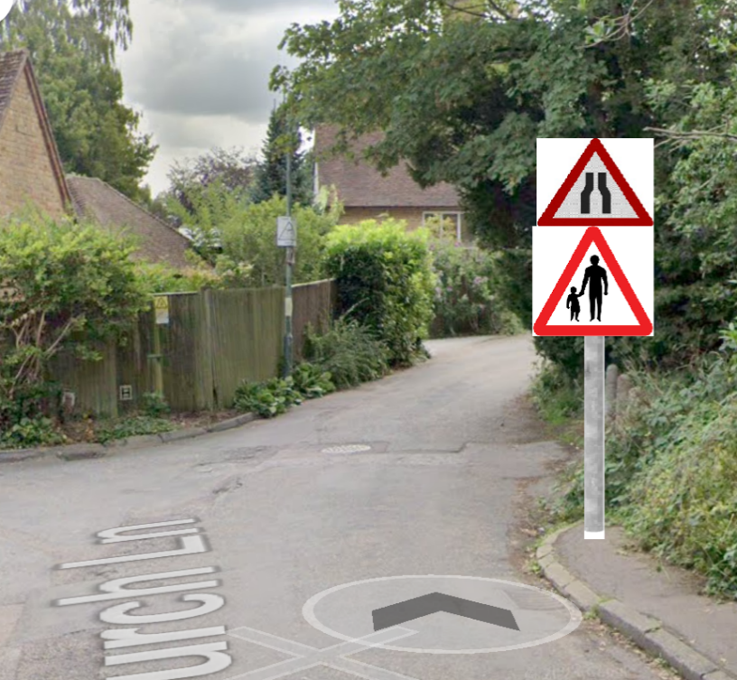  I don’t believe a matched sign at the other side will be needed, as it is a dead end and doesn’t widen up, so drivers coming from that direction are already aware the road is narrow and there is no footway.  21/02/24 - there is no sufficient room for a sign to go along this road, only suitable place is where there is a lamp column by Danefield which has a mirror on it so cant go there. There is no personal injury collisions and speeds show more than compliant. As it is a dead end it will be regular road users who know this road so would be wary of this road narrowing here.
 | Birling Avenue/Mynn Crescent | Dangerous and inconsiderate parking on the junction | R e q u e s t f o r D Y L s extending 10 metres from junction | These requests for DYLs will need to be priortised, as we will be unable to process all of them. TRO cost is £2500 and the lining working itself is likely to be around £150 for each set of lines.  04.11.22 - This is on the list awaiting assessment.  31/01/23 - Comment from P&A: Normally we only look to install double yellow lines where there is a safety critical element or as part of a crash remedial measure, neither apply at these locations. The parish could liaise with the Borough Council parking department, to establish whether the Borough would be willing to implement and enforce these lining requests. If the Borough are not willing to enforce the lines, they wont have any effect. If after consulting with the Borough the PC wish to proceed, they will have to look at funding the whole scheme themselves.
 | Manor Close junction with Yeoman Lane | Inconsiderate parking causing access and egress issues from Manor Close into and out of Yeoman Lane | R e q u e s t f o r D Y L ’ s extending 10m into Manor Close | These requests for DYLs will need to be priortised, as we will be unable to process all of them. TRO cost is £2500 and the lining working itself is likely to be around £150 for each set of lines.  28/10/22 - DYL priority No4. GM and ET to discuss with P&A, there is already a TRO being written for Maidstone district. This could potentially be added on.  04.11.22 - This is on the list awaiting assessment.  31/01/23 - Comment from P&A: Normally we only look to install double yellow lines where there is a safety critical element or as part of a crash remedial measure, neither apply at these locations. The parish could liaise with the Borough Council parking department, to establish whether the Borough would be willing to implement and enforce these lining requests. If the Borough are not willing to enforce the lines, they wont have any effect. If after consulting with the Borough the PC wish to proceed, they will have to look at funding the whole scheme themselves.
 | Sandy Mount | Inconsiderate parking on bend from end of permitted parking bays to outside no. 27 | Request for DYLs on both sides of the road on this bend | These requests for DYLs will need to be priortised, as we will be unable to process all of them. TRO cost is £2500 and the lining working itself is likely to be around £150 for each set of lines.  31/01/23 - Comment from P&A: Normally we only look to install double yellow lines where there is a safety critical element or as part of a crash remedial measure, neither apply at these locations. The parish could liaise with the Borough Council parking department, to establish whether the Borough would be willing to implement and enforce these lining requests. If the Borough are not willing to enforce the lines, they wont have any effect. If after consulting with the Borough the PC wish to proceed, they will have to look at funding the whole scheme themselves.
 | A20 Ashford Road | Speeding Traffic  Vehicles travelling at 60mph + at National speed limit suddenly entering 30mph built up area and failing to adhere to this sudden change in speed limit. Excessive speeds being recorded. | Extend start/end of 30mph zone to village boundary opposite Gore Cottage OR  Make start of 30mph zone more visible AND  Reduce speed limit from national speed limit to 40mph from Roundwell/ A20 Junction. Speed review based on crash history, change in use of side roads, new car park, tailgating, residents support and speed surveys.  Clearly defined 50/40/30mph zones from Hollingbourne as on the A20 through Harrietsham  Cycle lane | Speed surveys carried out by BPC  - May 2021. Results forwarded to KCC JULY 2021  4/10/21 - KCC to arrange additional speed surveys further towards Roundwell and look at installing a 30mph roundel at the terminal signs into village  7/10/21 – Job raised and funded by KCC to install new roundel  7/12/21 – Meeting with PC to discuss. Will look at enhancing gateway into village by introducing dragons teeth.  Site visit carried out – Currently looking at offering the parish council 2 options with costings to narrow down gateway into village which will slow traffic down. Will share this as soon as it is available.  29.06.22 - KCC covered investigation and design costs. Options emailed to Parish with associated outline costings.  28.10.22 - GM and ET discussed at meeting today the options presented. PC would prefer option 1, this will cost at minimum £15k. PC also asked about making the A20 50 or 40mph from Junction 8 or Roundwell to when the 30mph zone starts at Lilk Hill.  GM and ET to raise enquiry with P&A to price up the gateway options and feasibility of speed limit change on A20.  CSM 12408812  31/01/23 - Design team are finalisng up the costing of this. I have been given a rough estimate of £5 - £8k.  05/07/23 – Works to be carried out 09/07  10/07/23 - Works completed, job 12406003
 | Otham Lane | Rat running through lane from A274 to A20  Speeding vehicles  Pedestrian safety -Single track road - no footway frequently used by joggers, dog walkers, horse riders, cyclists | Erect speed signs Designate as a quiet lane | BPC traffic survey carried out May 2021. Results forwarded to KCC July 2021.  25.10.22 - please can these results be resent to west.highwayimprovements@kent.gov.uk.  28.10.22 - GM and ET have a meeting on Tuesday to discuss potential extra signage on this road, to improve pedestrian safety.  Re. Quiet Lanes, KCC does not currently have a policy on Quiet Lanes. There is no enforcement of who uses them and no changes generally to speed limits as most rural lanes are unrestricted. The aim of Quiet Lanes is to help preserve the character and tranquillity of rural areas and encouraging an increase in non-motorised users, whilst maintaining vehicular access. The idea is to make motorists more aware of non-motorised users and, over time, to reduce the number and speed of motor vehicles by changing attitudes ('hearts and minds' of local residents and other road users) rather than lowering the speed limit or using physical measures for enforcement. Ideally Quiet Lanes link homes with shops, bus routes, schools, workplaces, village halls, pubs and other local amenities, allowing people to use non-motorised modes of transport in preference to cars for short journeys.  The rural roads should already have low traffic flows travelling at low speeds and the designation of “Quiet Lanes” should not be used as a traffic calming device or preventing rat-running. The aim is to preserve the character of the rural roads by seeking to contain traffic growth.  Generally to date Quiet Lanes have consisted of no more than a small post with a small sign stating it is a quiet lane and maybe local advertising of the fact.  08.11.22 - Potential for extra bend warning signs and SLOW markings on the carriageway. Quiet Lane status is not appropriate for this road, given the above information and the speed limit. KCC can fund this, if the PC are in agreement.  05/07/23 – P&A currently investigating some single track signage at the top of Otham Lane, ATC has also been ordered.  06/10/23 - ATC found low speeds and average vehicle volumes, no particular issue highlighted via the ATC. There is still potential for the signing project we have previously highlighted.  06/12 - Otham Lane road narrows sign to be funded by PC. GM to double check with Designers and will raise invoice for design fee.  11/04/24 - Design still with Designers to draw up. GM has chased this.  08/10/24 - This job has a completion date of 04/11/24
 | Ragstone Road/Gault Close | Parking on corners, particularly at school times, poor visibility and some blocking of drive ways  Double yellow lines were recently painted on the corner of Greensands & Ragstone Road, moving the problem parking further up and down Ragstone Road. | Double yellow lines on corners | 06/12 - We can do this, funding will need to be discussed however. Although the notes do highlight the issue this may cause, just something to consider.  06/12 - Decided to keep this on hold, as parents will need to park somewhere and it may push the parking to an even less suitable alternative.
 | Roseacre Lane/Ashford Road | Parking on Roseacre Lane, blocking the road and pavements | Extended double yellow lines (as on The Landway/Ashford Rd) | 06/12 - Please can the PC share exactly where the problem is. If we are to line here, the problem will be shifted elsewhere, which may be worse.  06/12 - Traffic pulls in quite fast from the A20 and is then met with parked cars. PC request is for DYLs up to the roundels, to allow cars to pull in safely.  21/02/24 - I agree with WG comments on installing dyl on the West side of Roseacre Lane to match the opposite side. Dyl to not go down to roundels as this will displace the vehicles futher down where not suitable  11/04/24 - this is now with our TRO team to start the public consultation.  08/10/24 - Ordered, awaiting lines to be painted
 | Spot Lane junction with A20 | Traffic builds up as cars often wait in the middle of the junction, as opposed to by the centre line when looking to turn right from the junction. | Lane markings in the middle of the lane | 06/12 - For P&A, can we do a lane marking in the middle of the lane, like the below, to advise drivers where to position in the lane to allow two cars to fit, one turning left and one right.  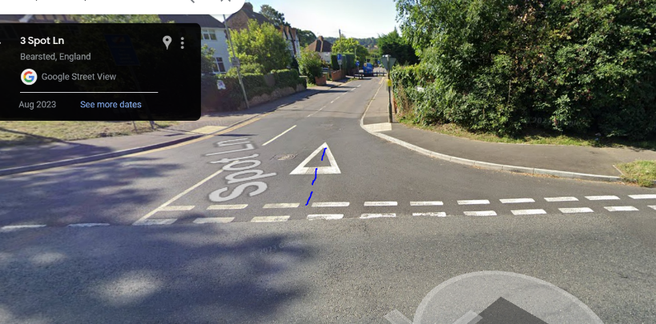  08/10/24 - Bellmouth is not wide enough to fit this unfortunately.

